Art of Toyin Ojih Odutola Lesson Guide

Use these slide by slide notes to follow along with the Toyin Ojih Odutola powerpoint. Learn more about Toyin Ojih Odutola by visiting her website: https://toyinojihodutola.com/

Slide 2
Toyin Ojih Odutola (b. 1985) is a Nigerian-American contemporary visual artist based in New York. She was born in Nigeria then moved to California and settled in Alabama. In a 2020 interview with The Guardian she said 'It wasn't until we moved to Alabama that I really got a history lesson in America, and what it is to be black'. A lot of her work is inspired by her story as an immigrant and a Black woman.

She has participated in exhibitions at The Drawing Center, Brooklyn Museum, The Studio Museum in Harlem, Contemporary Jewish Museum, Institute of Contemporary Art in Boston, The Renaissance Society, Seattle Museum of Art, Museu de Arte de São Paulo, the Menil Collection, as well as the 12th Manifesta Biennial in Palermo, Italy.

Public collections of her artworks are held at the Museum of Modern Art, New York; The Metropolitan Museum of Art, New York; National Portrait Gallery, London; Whitney Museum of American Art, New York; The Art Institute of Chicago; and the Smithsonian National Museum of African Art, Washington DC, amongst others.

Slide 3
What similarities or differences do you see between these three photos?

Odutola‘s work mostly consists of the use of black ballpoint pen ink, but she also incorporates pencil, pastel, charcoal, and other drawing materials. She often uses the skin of her subjects as a landscape for her work. By depicting the individuals in her paintings without any embellishments or any other way to give a sense of their identity, she is showing the audience how arbitrary an identity may seem once the things that make us who we are altered or simply disregarded.
Her work titled “The Treatment” which is from 2015-2017 (not shown in the powerpoint) is centered around the idea that when one is systemically indistinguishable from a group it can lead to a lack of individuality and dehumanization. The idea that all members of a community are the same are simply not true because everyone has their own sense of self. So, assumptions and stereotypes are so harmful to the progress we’re trying to make as a society and as individuals.

Slide 4:
Toyin also creates new narratives in her portraits.

These pieces are from an exhibition titled “A matter of fact” in the Museum of African Diaspora in San Francisco. Through this exhibition, she tells the story of two fictional aristocrat Nigerean families by highlighting their wealth and lifestyle if colonialism and slavery had never disrupted their country. Her work challenges social and political identities by visually translating different narratives about race, identity and class. She really challenges identities by making the audience think of what is and what could have been.

Slide 5
Identity and Hair in the African-American Community Brief History

Hairstyles were an important part of African culture and identity, symbolizing group, status, spirituality, and more. Because of the harsh conditions of slavery, many enslaved individuals were unable to maintain their African hairstyles. Some places even passed laws to restrict them. For example, the Tignon Laws, passed in 1786 in Louisiana forced black women to wear headwraps “as a visible sign of belonging to the slave class, whether they were enslaved or not” NPS Ethnography: African American Heritage & Ethnography

Others were able to keep their traditional hairstyles, finding one of the only forms of control and freedom during under enslavement. Despite the oppression of slavery, traditional African hairstyles including braiding, twists, and knots were passed down through generations.

Slide 6
In the early 20th Century, black women adopted straight European hairstyles that were considered more socially acceptable. Tools such as the ‘hot comb’ made popular by Madam CJ Walker and her “hair culturists”, and chemical relaxers, first invented by Garrett A. Morgan 1909, enable black women to straighter their hair.

African Americans and people of color encountered anti-Black, racially discriminatory practices daily. The “Paper Bag Test” (a test were a brown paper bag was held in comparison to an individual's skin color to deny entry) and the “Comb Test” (where if a fine tooth comb couldn’t pass through a person's hair they were denied) are just two examples of many.

The normalization of black women and men assimilating into white culture by altering themselves (sometimes referred to as ‘Lily Complex’) occurred throughout the 20th century and today. It can be either an unconscious or conscious effort.

Slide 7
Some examples from the early 20th Century of European hairstyles/ straighter hairstyles worn by people of color.

Slide 8
Black Power and Black Pride

As the Black Power Movement of the 1960s and 70s gained momentum and popularity, so too did traditional African hairstyles such as the afro, beaded braids, dreadlocks, and knots. By wearing traditional African hairstyles, people were resisting and rejecting Eurocentric standards and embracing blackness.

Simultaneously, racial discrimination against hair was occurring. Jenkins v. Blue Cross Mutual Hospital in 1976 was an early case of hair discrimination in the workplace. Though legally black Americans could wear any hairstyle, hair discrimination in the workplace and in school was prevalent.

Slide 9
In the 1980s and early 90s looser curls, straight hair, and use or chemical relaxer took over in popularity. The mid-late 90s and 2000s saw a renewed increase of natural hair, waves, braids, twists, dreadlocks, weaves and other styles. Unfortunately, this brought about an increase in court cases against hair discrimination.

Since then, even more recent discrimination cases have occurred:

Malden Charter School suspensions of Deanna and Mya Scot for braids- 2017
Barbers Hill Independent School prohibiting Kaden Bradford and his cousin De'Andre Arnold from attending school with dreadlocks – 2019/2020

Slide 10
Only 7 states have passed laws against hair discrimination: California, New York, New Jersey, Virginia, Colorado, Washington, Maryland.

Takeaway:

Hairstyles have been an important part of African culture and identity- symbolizing group, status, spirituality, individuality, and more- for hundreds of years. In American, restrictions put on black people and how hair is worn has sought to limit black expression and non-Eurocentric culture. Despite these challenges, individuals have found creative and versatile ways to express themselves through their hair.

Recently, the House of Representatives passed a federal bill titled the The CROWN Act (Create a Respectful and Open World for Natural Hair), which ensures protection against race-based hair discrimination, said the U.S. House of Representatives passed a similar bill ending hair discrimination. The bill is currently waiting to be addressed in the U.S. Senate.

Slide 11
Toyin Ojih Odutola’s series entitled These Garlands Prove Nothing explores many of the ideas and history discussed above.

“I remember as a teenager feeling pressured to be a certain way, to be very American and I knew that didn’t make sense. I was like a lot of people — a combination of two very divergent cultures,” Toyin Ojih Odutola from “My Country Has No Name”, The International Review of African American Art

Craft Activity:

Create a work of art inspired by Toyin Ojih Odutola. Print out a photo of a person or people on regular printer paper. Use Carbon Paper below the image and trace the details in the photo.

Recommended Supplies:
Carbon paper
A picture printed on regular paper with several people in the composition.
Black paper
White paper.
Black colored pencil
White colored pencil
Glue

Use the image below as inspiration.
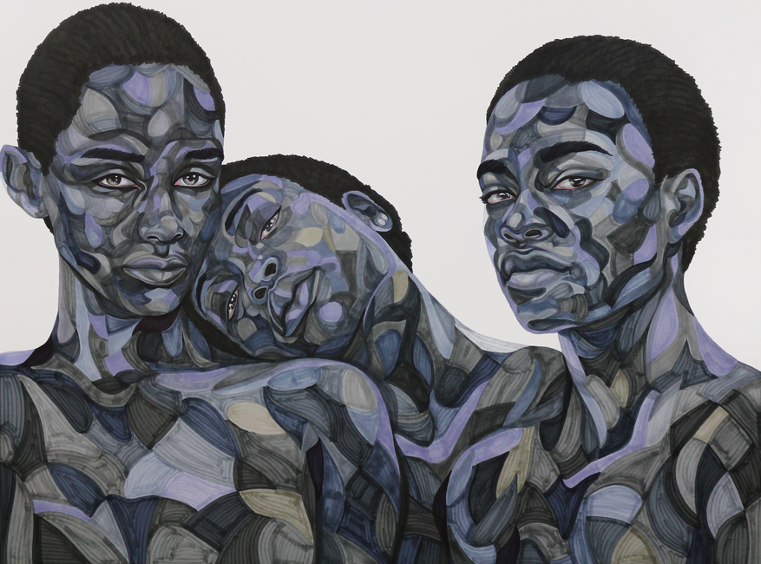

Toyin Ojih Odutola Untitled (Us Three), 2015

